Party scenario
How many apricots will we each have if 1kg is shared between 12 of us?  There are roughly 30 apricots in one kilogram. | There are 40 sandwiches to share between 12 guests. How many will each guest be able to have?  What shall we do with the spares?
Here is a cake, we need to share it between the 12 people at the party.  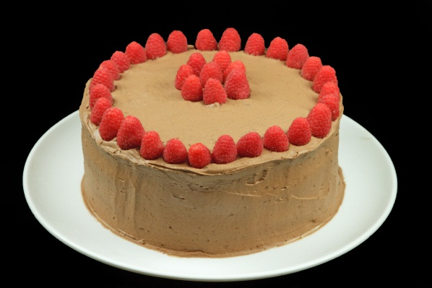  How do we do it? | There are 5 pizzas. How can we share them between the 12 people?  
We have 5 litres of juice for a party of 12 people. How many 120ml glasses will it fill?  How many glasses each will that give everyone? | I am making invitations for a party and want them to be 10cm by 12cm. How many will I be able to cut out of each A4 sheet of card that I have?  How many sheets of card will I need to make 12 invitations?
I am making bunting to hang across the room. How many flags will I need to make to reach across the diagonal of the hall measuring 6m to 7m?  You will need to think about the size of the flags, their shape, the tape or string they are fixed to and the gaps between them.  To put them across both diagonals and along all four of the sides, how many more will I need? | I have 3 bags of 15 balloons to decorate the hall. How many groups of 4 can I make?  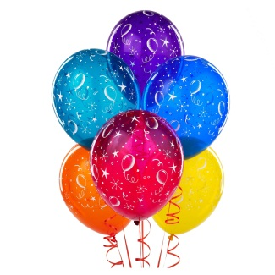
If 12 people come to the party, how can I divide them into teams?  What would be the best way to do this? | If 12 people come to the party and they all go bowling by car, how many cards will be needed if each car can take 5 people? How many cars will be needed if each car has to have an adult to drive in in additional to the party guests?

